Expobar Brewtus IV Espresso Maintenance Notes – Sutter
These are my observations in maintaining a Expobar Brewtus IV-R expresso machine with Rotary Pump - Stainless Steel. I purchased it on 10/05/2013 from Whole Latte Love for $1999.00
With the goal of reducing scale, I installed an inline filter in the supply line to this plumbed machine;
Filter Housing: SX2-11 Part # 160-50131
Filter: https://optipurewater.com/products/ctos-10/
Backflushing: About once a week, I back flush the portafilter with Urnex Cafiza I insert a blank in the portafilter in lieu of the double shot basket, place ½ teaspoon of the product in the portafilter and then backflush by “pulling 3 or 4 shots”. I then remove the blank, replace it with the double shot basket and pull 3 or 4 more coffee-less shots until the water runs clear. On occasion, I have substituted TSP for Cafiza.
Descaling: To descale the Brewtus IV, in a bucket, I dissolved two ounces of Dezcal descaler in 64 ounces of water. With a 3 way valve in the in line water supply, I switched the supply source from the cold water line of the house to the bucket. Then, I sucked the descaler solution into the espresso machine, running it through the portafilter as if I were pulling a shot.
I captured the descaler solution in a glass jar and dumped it back into the bucket, repeating the process several times until I was confident that the boiler was filled with descaler solution. I then repeated the process with the hot water wand until that boiler tank was also full of descaler.
Next, I turned off the espresso machine and let it sit for 7 hours. Finally, I changed the valves so that the water supply was once again coming from the house cold water line.
I turned on the machine, allowed it to heat up to operating temperature (203 degrees F) and proceeded to flush both boilers, running one gallon of water through each via the portafilter and the hot water wand.
When I began to get greatly reduced water flow from the hot water wand, I disassembled the aerator and cleaned it I first suspected scale buildup in the boiler. However, I decided to check the hot water wand aerator first since the flow seemed stronger if I removed it.
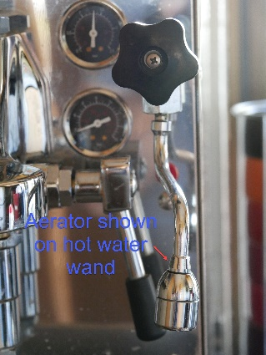
The aerator screen consists of three parts. They are pressed together. I separated them by inserting a knife edge and tapping the knife gently with a hammer until the three pieces separated.
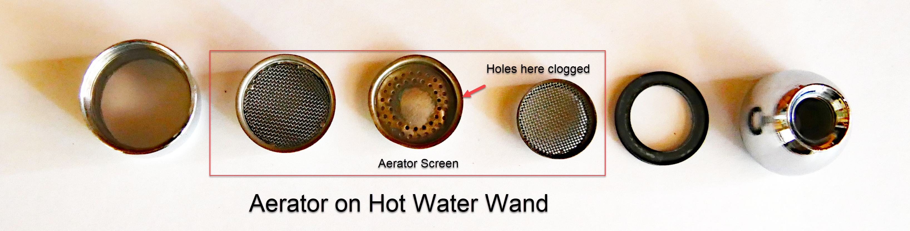
The arrow shows the part that needed the most cleaning.
Cleaning the aerator restored full flow to the hot water wand.
Repair Operations
At one point, the Brewtus IV began to make a loud hissing sound. Taking out the 3 screws that hold the top plate of the machine gave me access to the insides of the machine.

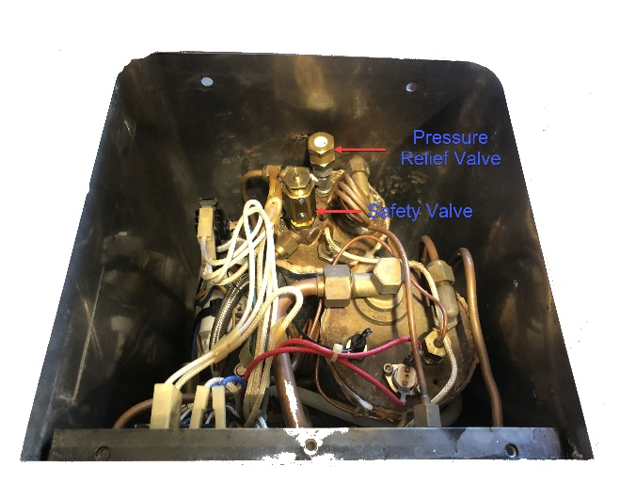
This is what I saw

I removed the top of the Pressure Relief Valve using a 20mm wrench and an adjustable wrench, making sure that the rest of the valve did not loosen from the boiler. I was able to clean the valve and stop the hissing. The second time that the problem arose, cleaning the valve didn’t stop the hissing. I had to replace the valve, ordering it from
Whole Latte Love.
On another occasion, I heard a loud popping sound and found a puddle of water on the countertop beneath the espresso machine. The problem this time was a failed Safety Valve. I replaced the part since it is not serviceable. Once again, I ordered the necessary repair item from Whole Latte Love

