Headwaters Adventures – Sacramento River Paddle
Three Day Kayaking Trip from Bonneyview to Bend Bridge
Overall Distance: 34.6 miles
Day One: Bonneyview Launch Ramp to Reading Island (17.7 mile leg)
Launch Point: Bonneyview Boat Ramp; GPS Coordinates: 40°23'24.55"N 122°11'49.00"W
Map: https://www.sacramentoriver.org/access_site.php?extent=15
Description of location: https://www.sacramentoriver.org/access_site.php?access_site_id=118
Optional lunch spot in route: Anderson River Park;
GPS Coordinates: 40°28'5.81"N 122°16'29.36"W
Description of location: https://www.sacramentoriver.org/access_site.php?access_site_id=112
Reading Island Campsite (limited beach space for landing and unloading);
GPS Coordinates: 40°23'24.55"N 122°11'49.00"W
Map: https://www.sacramentoriver.org/sac_river_atlas.php?extent=73
More at https://www.sacramentoriver.org/access_site.php?extent=14
Redding Recreation Management Area Narrative of Reading Island at
http://www.ohranger.com/redding-rec-management-area/poi/reading-island
Details of Reading Island Fishing Access at
https://www.sacramentoriver.org/access_site.php?access_site_id=107
Day Two: Reading Island to Massacre Flat (10.7 mile leg)
Maps: https://www.sacramentoriver.org/access_site.php?extent=14
and https://www.sacramentoriver.org/access_site.php?extent=13
Launch Point: Reading Island
Massacre Flat Campsite (ample space for landing and unloading)
GPS Coordinates: 40°19'2.88"N 122° 9'7.79"W
More at https://www.sacramentoriver.org/access_site.php?access_site_id=107&activities=Kayaking%2FCanoeing
Day Three: Massacre Flat to Bend Bridge Park (6.2 mile leg)
Launch Point: Massacre Flat
Map: https://www.sacramentoriver.org/access_site.php?extent=13
Campsite: none (End at Bend Bridge Park - ample space for landing and unloading)
GPS Coordinates: 40°15'49.03"N 122°13'23.63"W
Description of Exit Point: https://www.sacramentoriver.org/access_site.php
Sacramento River; A Guide to Recreation and Public Access (good overview of entire river)
https://www.sacramentoriver.org/index.php/sac_river_atlas.php
Maps by Region
(Click on opening map for specific regional maps)
https://www.sacramentoriver.org/access_site.php
This information is provided by Ralph Sutter. It was believed to be accurate when created. Use it for trip planning, not navigation. User assumes all responsibility when using this resource.
Additional Resources
Google Earth Pro KMZ Tour from Bonneyview to Bend Bridge
Download the file http://www.fullbean.com/kayak/kmz/bonneyview-bend.kmz and open it with Google Earth Pro.
This will automatically begin playing a movie that simulates flying from Bonneyview to Bend.
Google Earth Pro is a free program. If you need to install it, download from https://www.google.com/earth/download/gep/agree.html
Good overview of region at https://www.sacramentoriver.org/access_site.php?activities=Kayaking%2FCanoeing
Route Map – Bonneyview Launch to Bend Take-out
Disclaimer: This map is for trip planning, not navigation. Use at your own risk
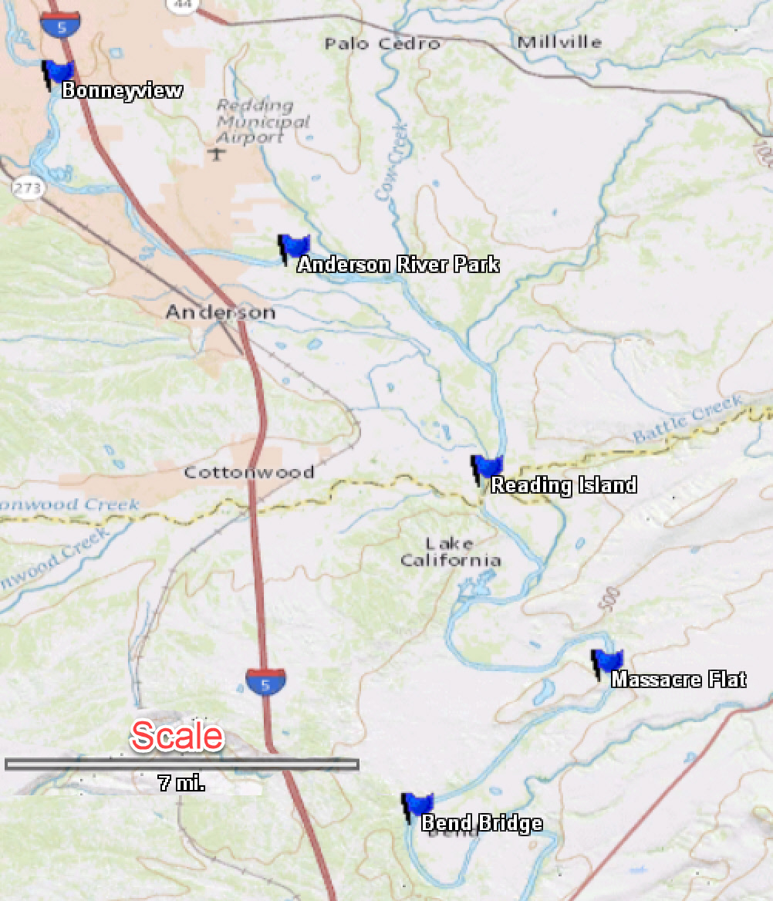

Trip Report filed 06/01/18
I joined 5 other paddlers for this three-day kayaking trip down the Sacramento River. The trip was offered by Headwaters Adventure and led by owner Bryan Anondson. There was no charge for paddlers using their own gear. Headwaters offered rental equipment at reasonable rates.
The itinerary for the three-day trip was as follows
Day One: Bonneyview to Reading Island (17.7 mile leg)
GPS Coordinates: 40°23'24.55"N 122°11'49.00"W
We met at the Bonneyview Hand-Carry Boat Launch at 9:00 am and were underway by 10:00 am. Four of the paddlers were veterans of this run. Jim let off with Bryan paddling a canoe and serving as sweeper.
This was the longest paddle and the most technical. The current was swift along most sections of the river, requiring strong strokes if paddling upstream. We opted for the calmest track but occasionally encountered moderate waves, boils, snags, wave trains and assorted obstacles.
We stopped for lunch at Anderson Boat Ramp.
GPS Coordinates: 40°28'5.81"N 122°16'29.36"W
If one overshot the landing, it wasn’t difficult to paddle back up stream.
The group then continued down river to Reading Island.
GPS Coordinates: 40°23'24.55"N 122°11'49.00"W
It was somewhat tricky to land and unload the kayaks due to deeper water and limited space at the take-out point. We landed one kayak at a time, pulling the first kayak ashore to make room for the next one. Holding position in the water while other kayakers unloaded required occasional strong upstream paddling.
Reading Island Campground offers several picnic tables and a fire ring. The tall grass had been recently mowed and the ground was soft. (No potable water)
Day Two: Reading Island to Massacre Flat (10.7 mile leg)
The second day paddle was much like the first though shorter. We encountered water conditions similar to those of the first day. In all cases, any technical sections were visible from considerable distance, offering us ample opportunity to decide the route we preferred.
Massacre Flat Campground (No potable water)
GPS Coordinates: 40°15'49.03"N 122°13'23.63"W
Massacre Flat Campground is a treeless area slightly higher than the river. It has a wide area for beaching kayaks, a fire ring and logs to sit on but no tables. There is an outhouse toward the back of the campsite. (No potable water)
Day Three: Massacre Flat to Bend Bridge Park (6.2 mile leg) (No potable water)
The final day’s paddle was short and could easily have been combined with Day Two. Water conditions mirrored those of the previous two days.
Headwater Adventure offered to shuttle paddlers back from the takeout point to the point of departure. The company provided free-of-charge a trailer for loading paddlers’ kayaks and gear.
There was an information kiosk at Bend Bridge Park offering free high-quality maps of the surrounding area. Look for a box on a post at the top of the parking lot.
GPS Coordinates: 40°15'49.03"N 122°13'23.63"W
YouTube Video of Trip: https://youtu.be/BFkQqJUw-gc
NOTE: The information provided here is believed to be accurate and up-to-date when created. However, it is offered without guarantee. It is intended for trip planning, not navigation. User assumes all risk in its use.
Ralph Sutter ralph@rsutter.com

