Ralph Sutter’s Raspberry Pi Notes
Linux SIG - 02/11/16
NOTE: If this page doesn’t display properly, view the document as an HTML file at www.fullbean.com/linux/raspberry-pi-notes.html
Raspberry Pi 2 Basic StarterKit  $44.99 from Amazon | Raspberry Pi 2 Complete Starter Kit  $69.99 from Amazon | Raspberry Pi 2 - Ultimate Starter Kit  $84.99 from Amazon
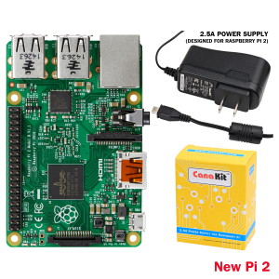 | 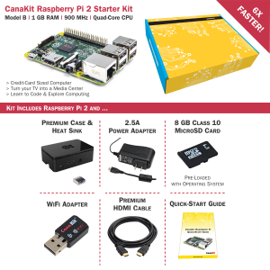 | 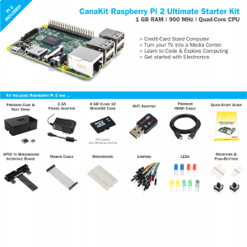
Kit Includes:  1 x Raspberry Pi 2 (RPi2) Model B Quad-Core 900 MHz with 1 GB RAM  1 x CanaKit 2.5A USB Power Supply with Micro USB Cable and Noise Filter - Specially designed for the Raspberry Pi 2 (UL Listed)  1 x CanaKit Quick-Start Guide | Kit Includes:  1 x Raspberry Pi 2 (RPi2) Model B Quad-Core 900 MHz with 1 GB RAM  1 x CanaKit 2.5A USB Power Supply with Micro USB Cable and Noise Filter - Specially designed for the Raspberry Pi 2 (UL Listed)  1 x CanaKit Quick-Start Guide  1 x 8 GB SD Card - Raspberry Pi SD Card pre-loaded with NOOBS (Class 10)  1 x CanaKit WiFi Adapter 150 Mbps - Supports Access Point Mode (AP) to allow for WiFi Hotspot hosting  1 x CanaKit 2.5A USB Power Supply with Micro USB Cable and Noise Filter - Specially designed for the Raspberry Pi 2 (UL Listed)  1 x High Quality Raspberry Pi 2 Case,  1 x Premium Quality HDMI Cable,  2 x Heat Sinks  1 x GPIO Quick Reference Card | Kit Includes:  1 x Raspberry Pi 2 (RPi2) Model B Quad-Core 900 MHz with 1 GB RAM  1 x CanaKit 2.5A USB Power Supply with Micro USB Cable and Noise Filter - Specially designed for the Raspberry Pi 2 (UL Listed)  1 x CanaKit Quick-Start Guide  1 x 8 GB SD Card - Raspberry Pi SD Card pre-loaded with NOOBS (Class 10)  1 x CanaKit WiFi Adapter 150 Mbps - Supports Access Point Mode (AP) to allow for WiFi Hotspot hosting  1 x CanaKit 2.5A USB Power Supply with Micro USB Cable and Noise Filter - Specially designed for the Raspberry Pi 2 (UL Listed)  1 x High Quality Raspberry Pi 2 Case,  1 x Premium Quality HDMI Cable,  2 x Heat Sinks  1 x GPIO Quick Reference Card  1 x Breadboard  1 x 40-pin GPIO Ribbon Cable  1 x 40-pin T-Shaped GPIO to Breadboard Interface Board  2 x Push Button Switches  1 x RGB LED  2 x Red LEDs  2 x Green LEDs  2 x Yellow LEDs  2 x Blue LEDs  10 x 180 Ohm Resistors  5 x 10K Ohm Resistors
Common specs for all of the listed Raspberry P1 2 Model B kits  900MHz quad-core ARM Cortex-A7 CPU  1GB RAM  4 USB ports  40 GPIO pins  Full HDMI port  Ethernet port  Combined 3.5mm audio jack and composite video  Camera interface (CSI)  Display interface (DSI)  Micro SD card slot  VideoCore IV 3D graphics core  ---  I purchased the Raspberry Pi 2 Complete Starter Kit  I also bought the following items  Raspberry Pi 8GB Preloaded (NOOBS) SD Card  $11.78  http://www.amazon.com/gp/product/B00ENPQ1GK  Inateck Bluetooth 4.0 USB Wireless Bluetooth Dongle $9.99  http://www.amazon.com/gp/product/B00N2E3ZHG  1byone WireWireless Bluetooth Keyboard with built-in multi-touch touchpad $22.99  http://www.amazon.com/gp/product/B00VRC6D3S | Because it has an ARMv7 processor, it can run the full range of ARM GNU/Linux distributions, including Snappy Ubuntu Core, as well as Microsoft Windows 10  Useful links  Respberry Pi on Wikipedia: https://en.wikipedia.org/wiki/Raspberry_Pi  Raspberry Pi Opening Page: https://www.raspberrypi.org/  Canakit: http://www.canakit.com/ - This is a retail site for purchasing Raspberry Pi related products  NOOBS Operating System Download Page: https://www.raspberrypi.org/help/noobs-setup/  Additional Operating Systems Download Site: https://www.raspberrypi.org/downloads/  OpenELEC Documentation: - Covers installation of Openelec on multiple operating systems  http://wiki.openelec.tv/index.php?title=Installation  Installing OpenELEC on Raspberry Pi: http://wiki.openelec.tv/index.php/Raspberry_Pi  The above URL contains a link to the site listed below  HOW-TO:Installing OpenELEC/Writing The Disk Image:  http://wiki.openelec.tv/index.php/HOW-TO:Installing_OpenELEC/Writing_The_Disk_Image#tab=Windows

Raspberry Pi Links
FORMATTING AN SDXC CARD FOR USE WITH NOOBS – Instructions here
https://www.raspberrypi.org/documentation/installation/sdxc_formatting.md
NOTE: If your SD card is 32Gb or larger, Windows formats it as exFAT. Raspberry Pi doesn’t understand that configuration and must be formatted as FAT32
SOLUTION
Insert SD card and download SD Formatter
https://www.sdcard.org/downloads/formatter_4/
Format the SD card with FORMAT SIZE ADJUSTMENT set to ON
Download FAT32 Format (which downloads as a single file named guiformat.exe)
http://www.ridgecrop.demon.co.uk/index.htm?guiformat.htm
Using guiformat.exe, format the SD card to FAT32
Download NOOBS from https://www.raspberrypi.org/downloads, choosing NOOBS from the operating systems offered
Extract NOOBS to a folder and paste the contents of the folder to the SD card
Run NOOBS, following the instructions at
https://www.raspberrypi.org/documentation/installation/noobs.md
You will be offered a one-time menu that offers to install any one of the following operating systems on your Raspberry Pi
Raspbian
Pidora
OpenELEC
OSMC
RISC OS
Arch Linux
I chose OpenELEC. Setup instructions for that OS are found at http://wiki.openelec.tv/index.php?title=Raspberry_Pi_FAQ and
http://wiki.openelec.tv/index.php/HOW-TO:Installing_OpenELEC/Writing_The_Disk_Image
Offer to do a live install of OpenELEC
DEMO OpenELEC on my Raspberry Pi showing
Network setup/WiFi Setup
Bluetooth keyboard setup
Content creation
Demo Music/Video/Pictures from attached Flash Drive (Mushkin)
Slideshow options and Playlists
Unsolved items
How do I create a single slideshow with files in more than one folder?
Is it possible to display .doc or .html files inside Kodi?

