Luminar AI Notes
View the Luminar AI Users’ Manual at https://manual.skylum.com/
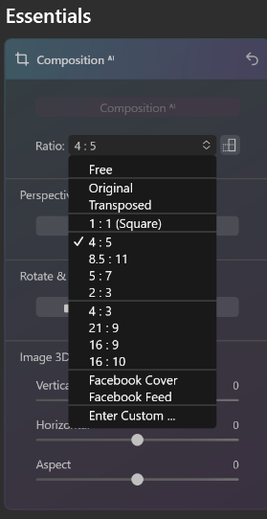
Also on the SLO Bytes Photo Group web site at https://www.slobytes.org/digital/documents/Luminar%20AI.pdf
Cropping
Crop by navigating to Essentials/Composition/Ratio/Free Like this
Straighten the Horizon with Essentials/Composition/Perspective
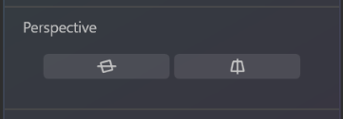

The Compare Button divides the screen with a vertical line
On the left, it shows the image before editing. On the right, it
shows that image after editing. The vertical line can be dragged
left or right to show the editing effects on more or less of the screen
Just to the right of the Compare Button is the Eyeball. Pressing and holding it shows the image before editing.
Releasing the button shows it with editing. The keyboard shortcut for this same action is \, the backslash key.
Keyboard Shortcuts (Windows)
Ctrl + [ Rotate Image Left
Ctrl + ] Rotate Image Right
Ctrl + Shift + R Revert to Original
Ctrl + + Zoom In
Ctrl + – Zoom Out
Ctrl + 1 Zoom to 100%
Ctrl + 0 Fit Image to Window
C Crop tool
Ctrl + J Clone & Stamp Tool
Alt Change Chosen Part for Cloning
Ctrl + E Erase tool
X Press the X key while in Crop mode to Rotate the Aspect
Ratio. Switch crop between portrait and landscape orientation.
Ctrl + I Invert the layer mask
Ctrl + Delete Clear layer mask
[ Decrease the brush radius
] Increase the brush radius
Shift + [ Decrease the brush softness
Shift + ] Increase the brush softness
X Toggle Brush/Erase Modes
To view the name of the file in the Catalog view, look in the lower right hand corner of the screen.
To view the name of the file that you are editing, look in the lower left hand corner of the screen.
L Switch to the Catalog Panel
T Switch to the Templates Panel
D Switch to Edit Mode and Panel
I Toggle Info Sidebar showing exposure information
E Switch to Export Panel
Ctrl + + Zoom In
Ctrl + – Zoom Out
Ctrl + 1 Zoom to 100%
Ctrl + 0 Fit Image to Window
; Compare
Masking replaces Layers in Luminar AI. The program does not have Layers per se but Masking achieves the same effect
Steps
Click on Local Masking Button

Click Add
Select the area to which you wish to apply the mask
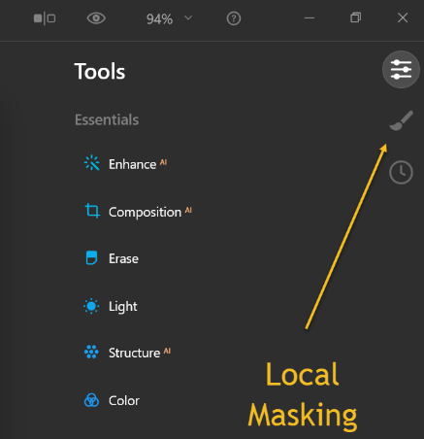
Click the Add button
Click the dotted button to the right of Paint Mask
Select Inverse to mask everything but the area you select
Paint the area, first resizing the radius of the tool if needed
Choose an Edit slider and adjust it
View the results on the image
Apply an edit to that area
Adding Custom Skies
Go to Tools/Creative (Scroll down)
Click on SKY AI
Click the down-facing arrow and go to the bottom
Click on the entry Load Custom Sky Images
Navigate to the folder in which they are located
Click on the single sky file that you want
NOTE: The second item in the Sky AI drop down menu will now be Show Custom Skies but clicking on any of those images will not load them. It will only display them. Add them singly as described above.

