Share Screen in Zoom
Zoom allows screen sharing. The Zoom initiator (Host) has this ability automatically and can authorize screen sharing for other participants too.
One chooses what to share. In the screen shot below, you can see that this Zoom user has several programs already open
They are File Explorer, Chrome, Outlook, Snagit, Word and Luminar as well as two Zoom tabs
In the Zoom Share Screen window below, you will notice that these opened programs appear as share options
File Explorer Chrome Outlook Word Luminar (Snagit does not)
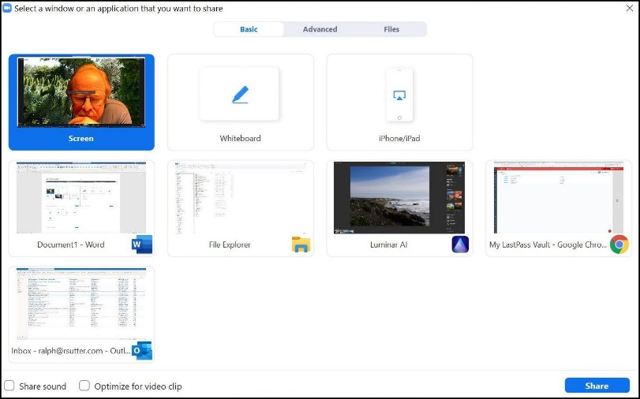
To share your screen, move your cursor to the bottom of the Zoom window and click on the Share Screen button
If you don’t see the toolbar, pause your cursor at the bottom and the toolbar will appear.
If the screen that you wish to share is already open, click it and then click on Share.
If it isn’t open, click Screen and then Share
NOTE
It does not work to click on File Explorer followed by the file or program that you want to open. You will remain inside File Explorer, not the item on which you clicked.
When you have finished sharing, click Stop Share at the top of the screen
Ralph Sutter
Current as of 02/15/2021

