Exporting Waypoints from DeLorme Topo USA 7.0 to Magellan Vantage Point

DeLorme Topo is the computer interface for the DeLorme Earthmate hand-held GPS unit. My units are a DeLorme Earthmate PN-20 and a Magellan Explorist 610.
Vantage Point is the equivalent software for the Magellan Explorist series.

Open the DeLorme software program, DeLorme Topo USA 7.0. This procedure may work with other versions too. I do not have any other versions of the program

Either open an existing Topo Project, somefile.tpx or create a new project, setting waypoints and charting routes.
From the Draw tab at the bottom of the screen, click on File. (See screen shot below)
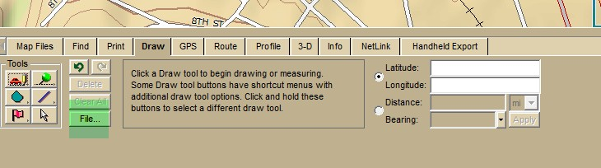

At the next screen, click on Export. In the File name box, enter any name.
Click the down arrow in the Save in window and choose the directory where you want to save the file. Leave the Save as type GPX File (*gpx).
Click Save.

(See screen shot below)

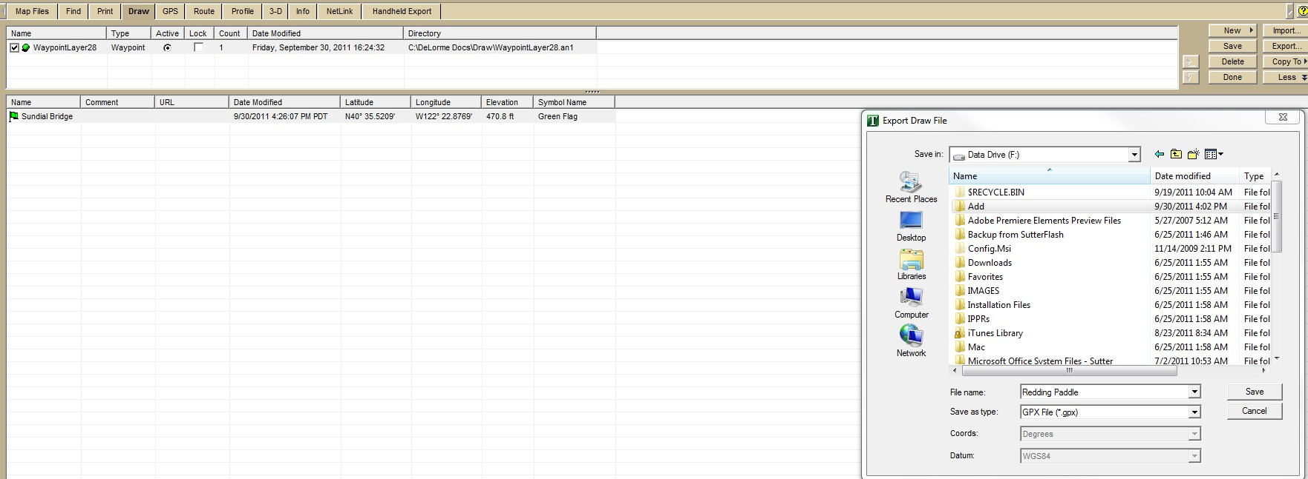

Open up Vantage Point, the Magellan software that provides the computer interface for your hand held Magellan GPS
unit.

Find the file that you exported from Topo USA 7.0 and open it with Vantage Point, not with Windows Explorer.

Vantage Point will open displaying a map that corresponds to the waypoints that you exported. If you want to see a list of waypoints, click on the My Journal tab on the left side of the screen.
To export the waypoints from Vantage Point to your Magellan hand held GPS, connect the hand-held unit to your
computer with the USB cable.
Once the unit is recognized, it will show up when you click the My GPS tab on the left hand side of the screen. A list of your waypoints becomes visible when you click on the My Journal tab.
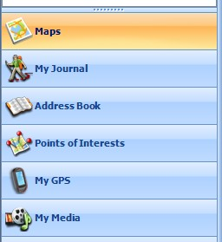

Click on the Sync button circled in the screen shot displayed below.

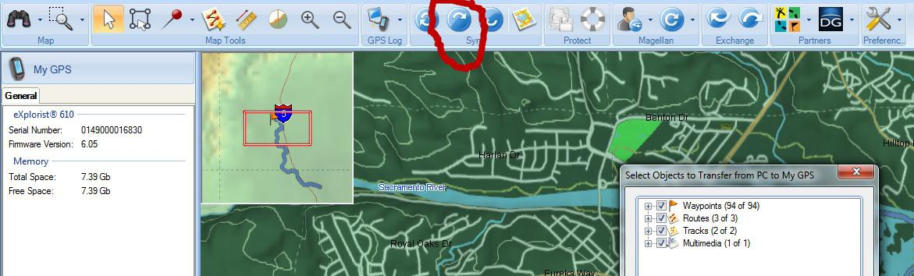
That will transfer from Vantage Point to your Magellan Explorist GPS hand-held unit all of the items that are checked. Useful tip.
The operating system that I use when I run Vantage Point is Windows 7 Ultimate 64bit. If I attempt to run the program while logged on to the computer as Administrator, Vantage Point always crashes in very short order. It is far more stable when I log on as a Standard User. I am at a loss to explain why.

A handy on-line resource for converting between numerous GPS formats is GPS Visualizer. Also useful is list of Frequently Asked Questions, especially the table of GPS file extensions

