Kayak Camping in the San Juan Islands
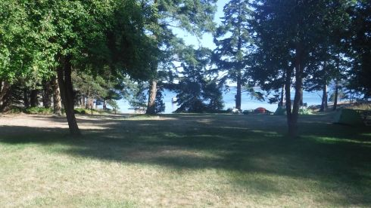
Click here for full resolution image
In July 2020, I booked a kayaking trip to the San Juan Islands through Alder Creek Kayaks, Portland, OR. It was a 4 day excursion to Orcas Island and beyond from July 23-26.
I boarded the Anacortes Ferry to Orcas Island at 5:30 am on the 23rd after having spent the previous night in the San Juan Motel, Anacortes. Note to self – Book reservations early for more ferry options.
The cost of ferry passage included the return trip. It took about an hour and 15 minutes to reach the Orcas Island Ferry Terminal. From there, I drove to West Beach Resort to meet up with the other 6 members of our group.
We loaded the kayaks and moved the vehicles to paid parking at the West Beach. Under windy conditions, we paddled the 7 miles from West Beach to the South Camp on Jones Island. Water was generally calm with light power boat traffic and minimal currents.
It took us about 4 hours to arrive at the campsite due more to our leisurely paddling than the rigors of the passage. At Jones Island, there is a sloping beach with logs washed up to the banks. Wooden stairs lead up to the camp site. We stayed at the group camp. It included a covered concrete pad with picnic tables, a BBQ and a fire ring. Plumbed water was available though it apparently is turned off at certain times of the year. We were able to gather downed branches and pine cones for the evening fires.
Due to the COVID Pandemic, we all wore a mask while in camp. The guide, Alex, and his girlfriend, Holly, prepared delicious meals for the 4 days of the trip.
On our second day, we first circumnavigated Jones Island, a 2+ mile paddle. Later that day, we crossed to Yellow Island. It is owned by the Nature Conservancy and boaters are not allowed to come ashore. We continued to McConnell Island where we ate lunch. The crossings were uneventful. We stayed in a group and paddled slowly, hugging the shorelines when not crossing from island to island.
The third day, we ventured out to Deer Harbor on Orcas Island, paddling around Crane Island before coming ashore. Deer Harbor offers a small store, paid showers and snacks though we did not avail ourselves of any of these services.
The return to Jones Island was punctuated by numerous power boat encounters. They were all far from the kayaks but our guide, Alex, had us stop in the water while they crossed.
After another excellent dinner, we waited until it got dark. At around 10:00 pm, donning headlamps, a group of us launched our kayaks and paddled a short distance to an uninhabited cove where we viewed the phenomenon of bioluminescence. Microscopic organisms glowed brightly when we agitated the water.
The fourth day, we broke camp and headed back to West Beach Resort. We opted to be on the water early to take advantage of favorable tides and light winds. Alas, our timetable slipped and we ended up paddling against the current much of the time.
Once at West Beach Resort, we retrieved the vehicles, emptied the kayaks, loaded our gear and headed for the Orcas Ferry Terminal. Though I had a reservation for the 10:30 pm sailing, I was able to catch an earlier ferry and was back in Anacortes by 7:00 pm.
Slideshow at https://youtu.be/cgaL6nGPgEs

