My Starlink Notes
I live in rural Arroyo Grande, CA. Those who live in Arroyo Grande proper can purchase Internet access delivered through fiberoptic cable, achieving speeds up to and beyond 1000mbps. However, I live beyond the service area for fiberoptic cable. I got my Internet via Advanced Wireless. I had a radio receiver attached to my house and generally got speeds in the range of 15-25Mbps down and 12Mbps up. I wanted faster speeds
Opting for Starlink Internet, I expected download speeds near 100Mbps. I had no specific expectations regarding upload speed.
I signed up to purchase the Starlink Kit on 02/19/2021. The service would cost $499.00 with a $99 deposit. The deposit was refundable if I later decided that I didn’t want to go through with the purchase.
In addition to the $499 cost of the kit, Starlink has a monthly bill of $99 with the option to cancel at any time.
Here is my timeline
Date | Event | Comments
02/19/2021 | Pre-ordered Starlink Kit | Placed a $99 deposit
12/15/2021 | Starlink indicates that the kit is ready to ship once that I pay the balance of the $499.
12/18/2021 | Starlink kit ships
12/20/2021 | Starlink kit arrives
12/20/2021 | I order the Pipe Adapter to mount the satellite on a pole @$37.54 including shipping | The Starlink kit comes with a base suitable for mounting the satellite on a flat horizontal surface. I wanted to install the satellite on a 2” pole attached to the gable of my house.
01/01/2022 | I order the Ethernet Adapter at @$21.45 including shipping | The rectangular Starlink kit does not have a port for connecting Ethernet. The round Starlink kit (no longer available) had Ethernet ports
01/01/2022 | I receive my first Starlink monthly bill | $99/mo billing
01/02/2022 | The Pipe Adapter arrives
01/27/2022 | The Ethernet Adapter arrives | It was back-ordered

Install Notes
I downloaded the free Starlink app before I attempted to install the satellite dish. It is available for both iPhones and Android devices. I used it to determine if I had a clear view of the sky from where I intended to install the dish. I panned the sky repeatedly but the app never finished scanning.so I did not rely on it.
I installed the dish on the gable end of my roof. It is attached to a 21/2” OD galvanized pipe fitted with the Starlink Pipe Adapter. I ran the 75’ of cable into my attic, through a hole in the ceiling and attached to the Starlink router.
Initially, I didn’t have the Ethernet Adapter so I couldn’t connect the Starlink router to any of my numerous Ethernet-connected device. The Wi-Fi signal from Starlink did not reach all areas of my house. Once that the Ethernet Adapter arrived, I connected it between the cable from the satellite and the Starlink router.
I then connected an Ethernet cable between the Starlink Ethernet Adapter and the Netgear Mesh router.
In order to take advantage of the Mesh router, I had to set the Starlink router to Bypass Mode.
You do this through the Starlink app. The app will warn you that in Bypass Mode, you won’t have access to the Starlink router. If you decide to re-enable the Starlink router, you will have to reset it by unplugging the power plug from the Starlink router three times in quick succession. This will return you to normal functionality i.e. no access to the Mesh router
I opted for Bypass mode. When I did, several things changed.
My Netgear Orbi RB40 router used to be at 192.168.1.1. It now uses 10.0.0.1,
My Synology NAS used to be at 192.168.1.55. That changed to 10.0.0.55.
What follows is my Speedtest.net history from before I changed over to Starlink to the present (01/29/2022)
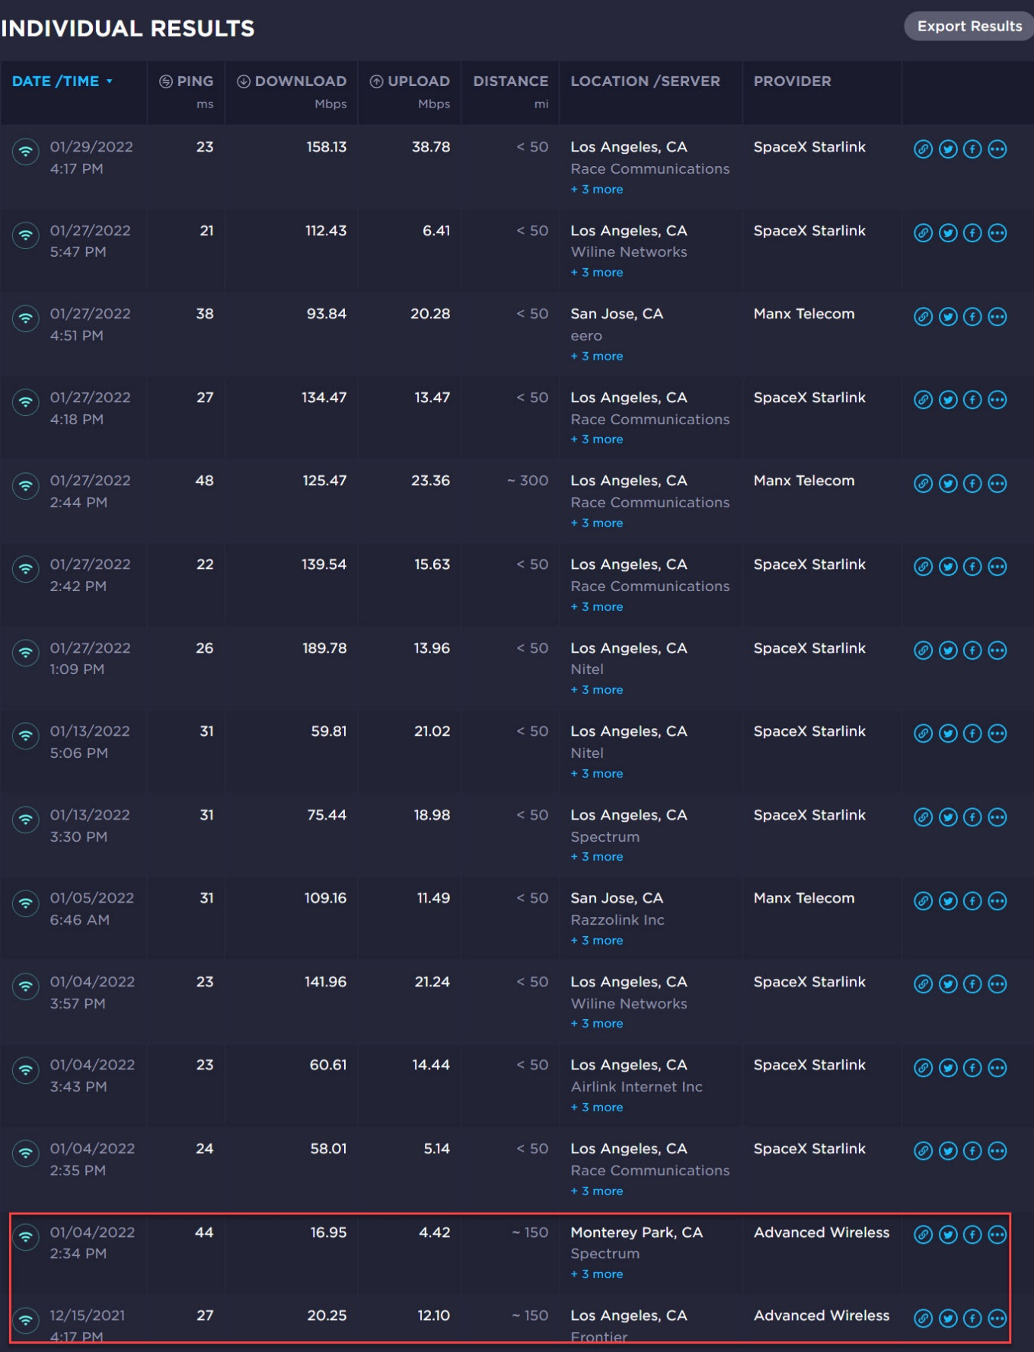
Ralph Sutter

