Find Google Earth Pro Location for myplaces.kml
Your saved Google Earth Pro locations are saved in the file myplaces.kml. To locate it proceed as indicated below
On your keyboard, hold down the Windows Key (bottom row of keyboard third key from the left) and press r
This will open the Run Terminal. In the Open box, paste in the highlighted text seen below %USERPROFILE%\AppData\LocalLow\Google\GoogleEarth
This action will take you to where your myplaces.kml file is located
If you would like to share your myplaces.kml data with others, attach your myplaces.kml file to an e-mail, instruct the recipient to open Google Earth Pro and then import myplaces.kml as shown below
In Google Earth Pro click on File and move the cursor down to Import
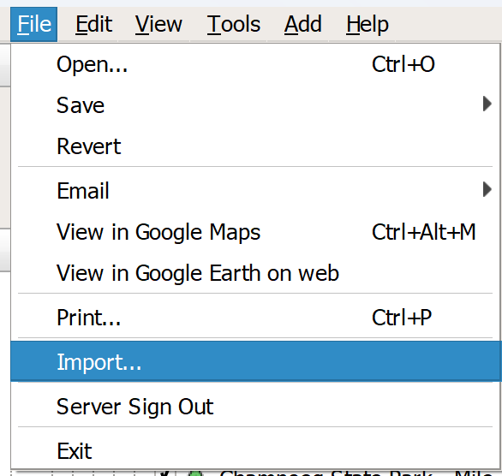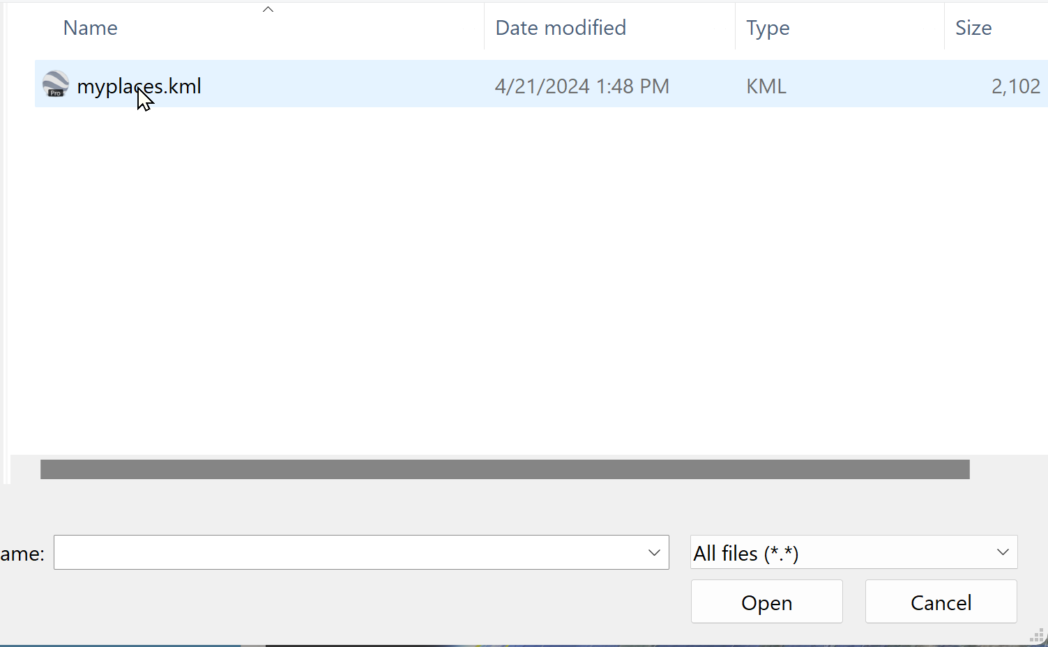
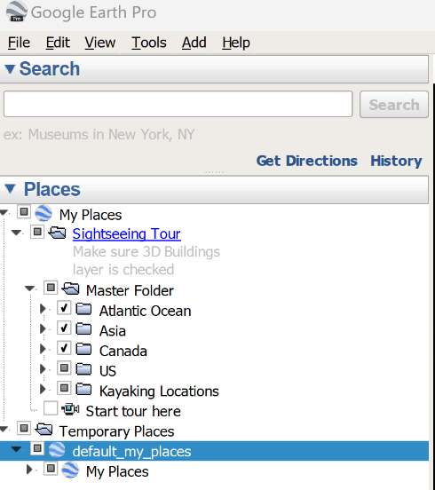
Clicking on Import will open up a browser window. Navigate to where the file myplaces.kml was saved. If the user is certain that he or she is looking in the right place but still doesn’t see the file, confirm that the user scrolled all the way to the bottom of different formats available and chose all files (*.*)The Import option will install all of the imported map data in the Temporary Places Folder of Google Earth Pro

