Identifying the Folder Where You Saved That E-mail
I use Outlook 365 as my primary e-mail client. I often save important correspondence in nested folders within Outlook.
Sometimes, when I move a message from the In Box to another folder, I inadvertently misfile it and can’t find it readily.
I locate wayward e-mails by using Outlook’s Search function As originally configured, the Search found the document(s) and I could then refile them properly but I wanted to know where I originally misdirected them.
Here is how I got that information; I added the In Folder column to my Outlook screen.
To do so, open Outlook and click on the View tab.
Select Add Columns
From Select available columns from, scroll the drop down menu
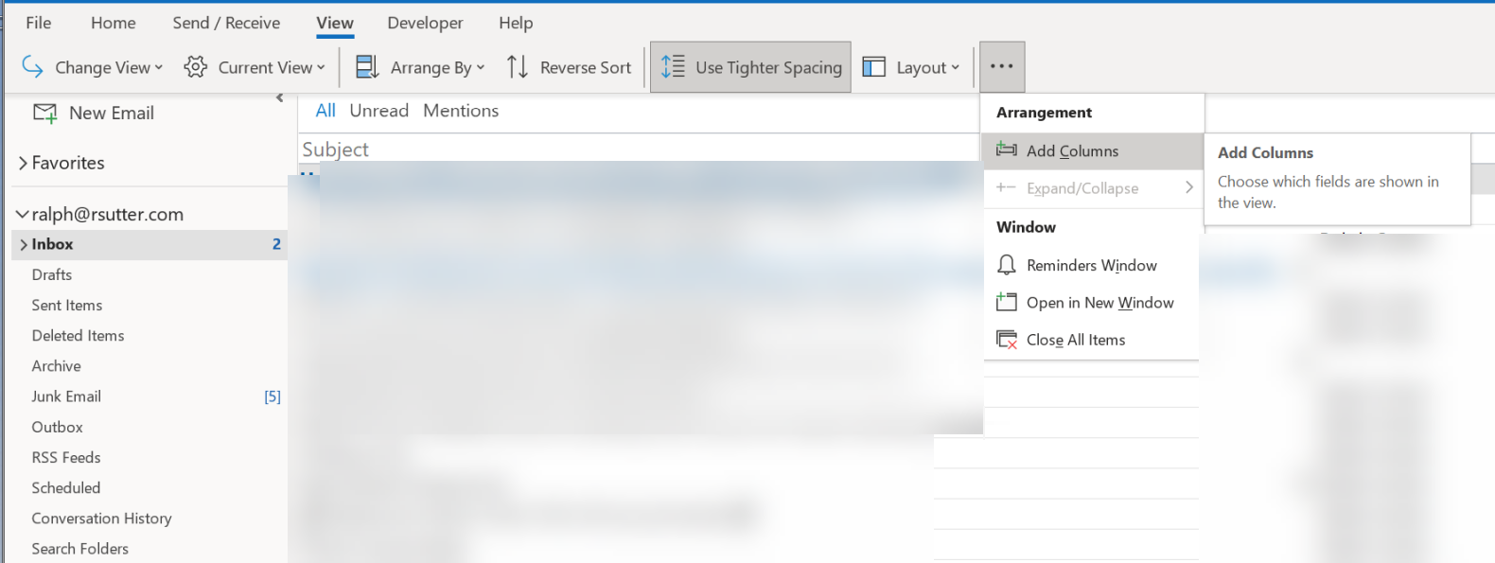
Choose In Folder and click the Add Button/OK
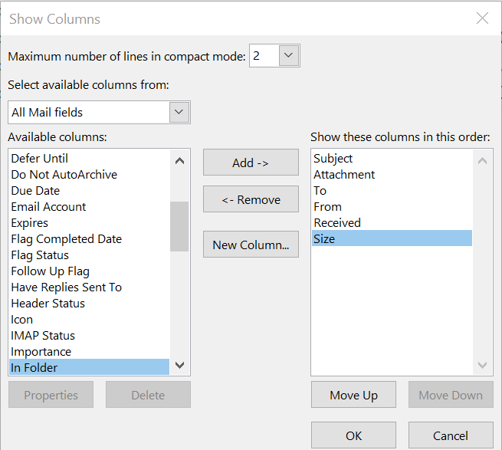
This will add the In Folder column to your Outlook screen

